Q1) WHY WE ARE USING THE CONCEPT OF HAWK AND DOVE?

Ans. We are using the concept of hawk and dove game theory because:

* It gives a better payoff for the quantum games using a random strategy and maximum payoff for pure strategy.
* It uses both pareto optimality and nash equilibrium concept to maximize the payoff.
* It removes the local correlations where both the players are unaware of the fact that an entangled state has been distributed amongst them.

Q2) WHEN WE USE THIS CONCEPT (WHEN TO USE HAWK PLAYER AND DOVE PLAYER)?

Ans. In our model, we need to classify the players acting as hawk or dove as these are two different types of the same species with different outlook and strategies.

Conditions of the game to be played as:

* Hawk being aggressive
* Dove trying to share the available resources.

Now, the tigers behave as hawk or dove in some situations depending upon the opponent it has to face as described in the table.

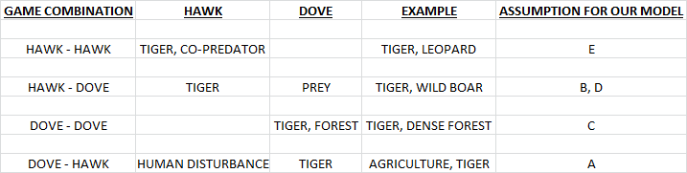

Q3) HOW TO USE THIS CONCEPT?

Ans. Steps to approach the concept:

1. Set up the selected landscape over the chosen grid matrix.
2. Find out the partial and complete occupancy matrix and thereafter label them as:

* “0” for outside landscape
* “1” for inside the landscape
* “identity” for boundary of the landscape

1. Identify the possible decision variable or the factors that are responsible for increasing or decreasing the tiger population.
2. Now we use the hawk and dove evolutionary game model to calculate the payoff of the matrix by the following strategy:

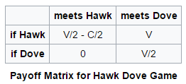

1. After the payoff matrix has been derived we calculate the scores for each grid by using the formula :

S[i][j] = ∑∑T[i][j]\*Parameter[i][j]\* (payoff)

1. Then we will be ranking our grids based on the following ways :

* On the basis of class size.
* On the basis of Centrality measures.
* On the basis of ground data.
* On the basis of any pre dominant factor, etc.

1. Thereafter we create our rank orders from the sample marking by categorizing them under certain intervals in the increasing order of numbers.
2. Next we find out the patches of the landscape where the population of tigers is maximum(as encoded by the green color of the grid in our model) and follow the steps:

* If completely occupied then add the grid to vertex set
* Else if it is partially occupied then stop the search and start new one for next ‘z’ value.

1. Then we apply kruskal algorithm to find out the minimum weighted graph.